Task :

1. Create a VPC with 2 subnets 2 route tables and 1 internet gateway launch 1 instance

Attach instance with EBS volume

**Creating a VPC**

1. Search for VPC and click on VPC

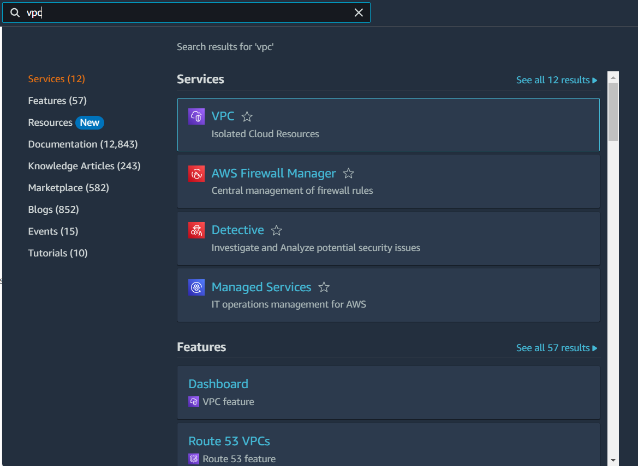

1. Click on ‘Your VPC’s’ and click on ‘Create VPC’

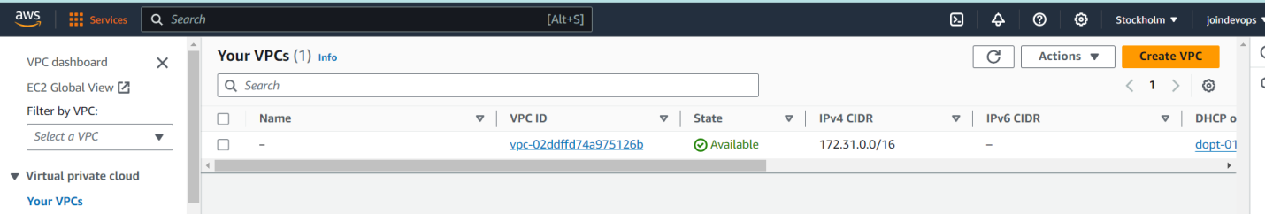

1. Enter VPC name as ‘my-vpc-01’, IPv4 CIDR as ‘10.0.0.0/16’ and click on create VPC

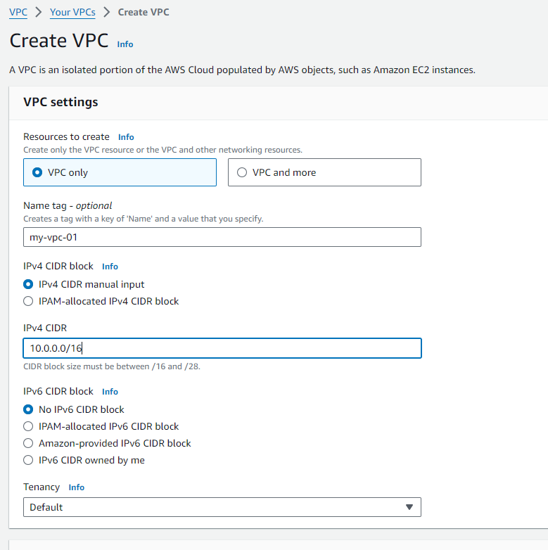

1. Create 2 Subnets , click on Subnets , click on Create subnet then select the created VPC and enter subnet name , availability zone, IPV4 subnet CIDR block

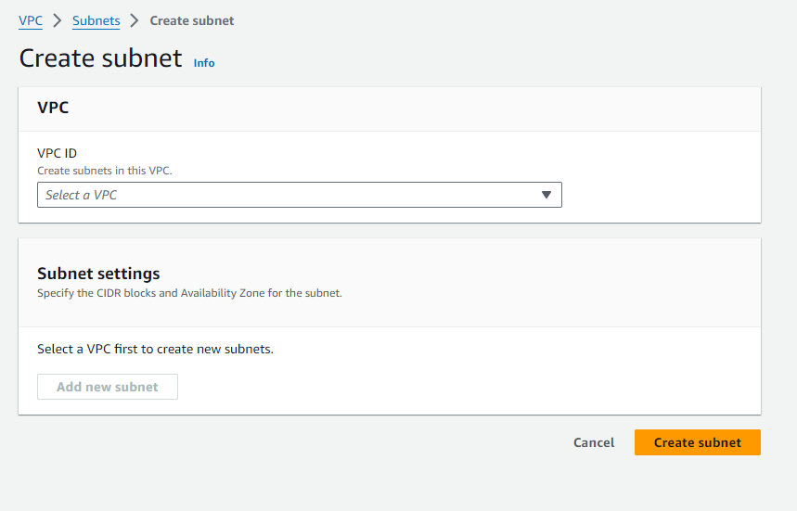

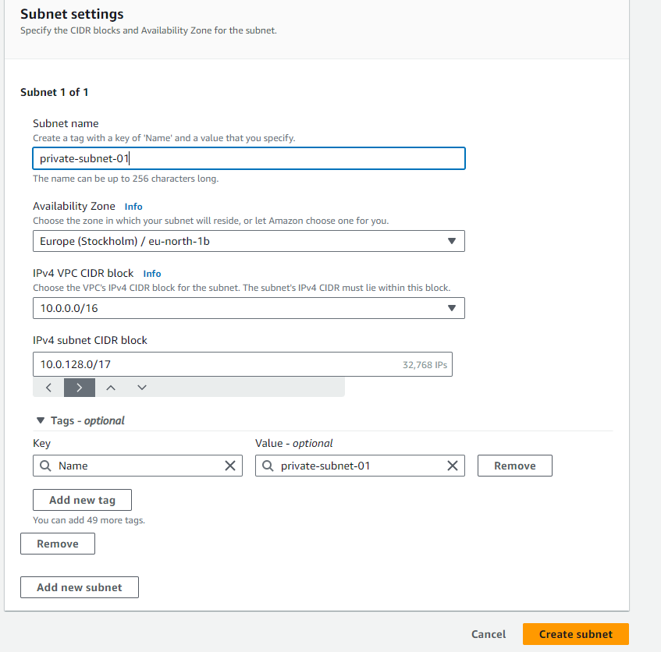

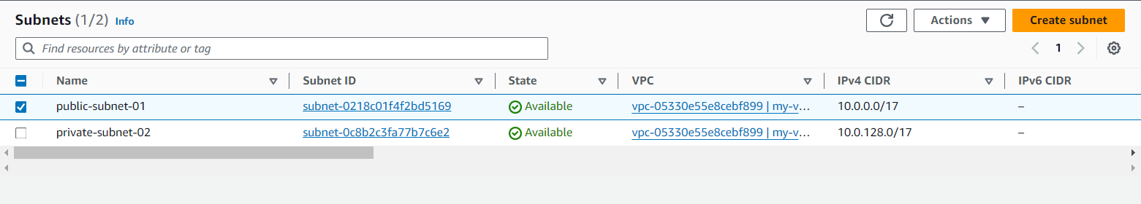

1. Create 2 route tables – click on routr tables , click on Create route table

Give route table name and select the created VPC , click on create route table

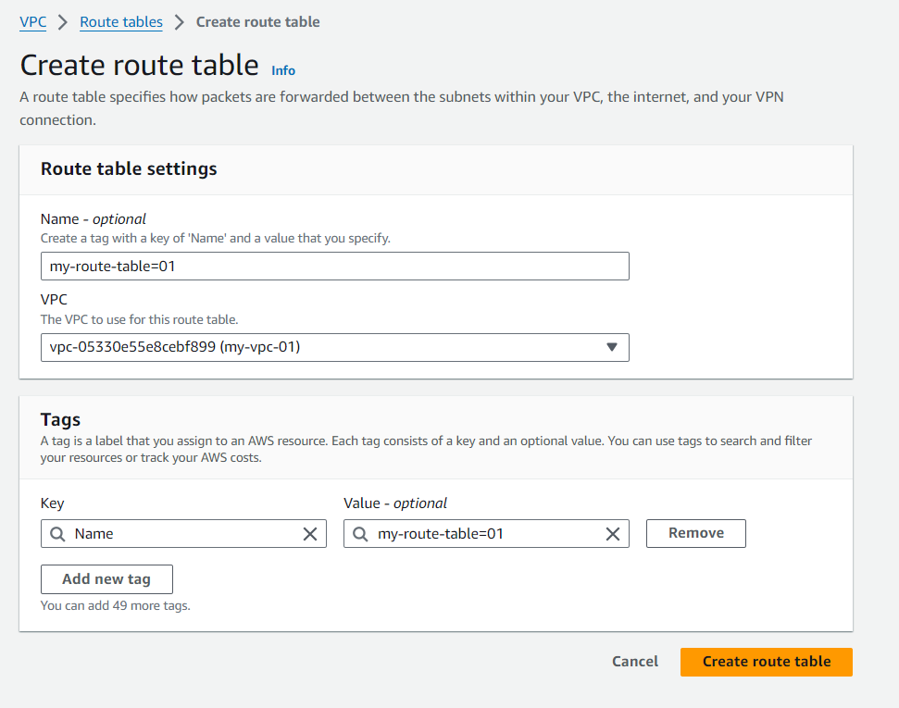

1. Click on Internet Gateway , click on Create Internet Gateway enter the internet gateway name and click on Create Internet Gateway

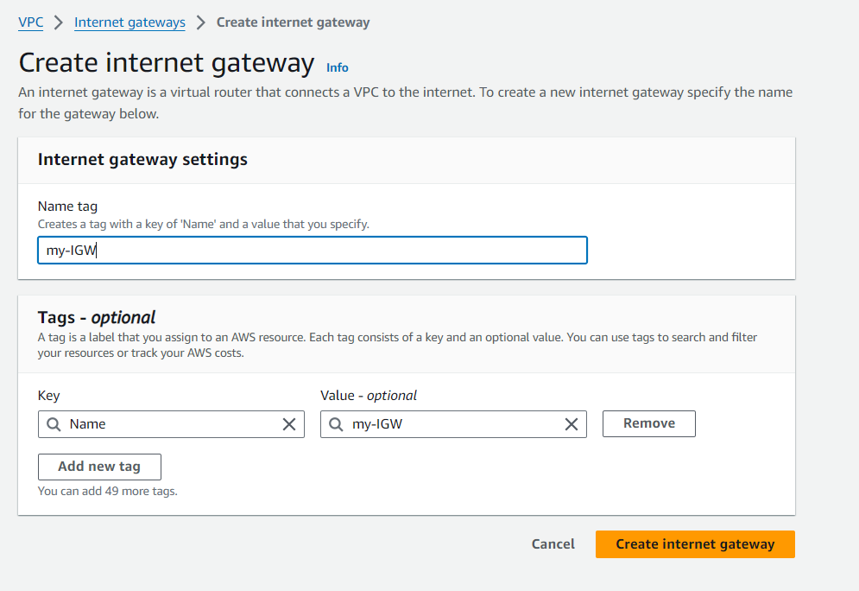

1. Attach internet gateway to VPC, click on attach to VPC – select the required VPC and click on attach internet gateway -

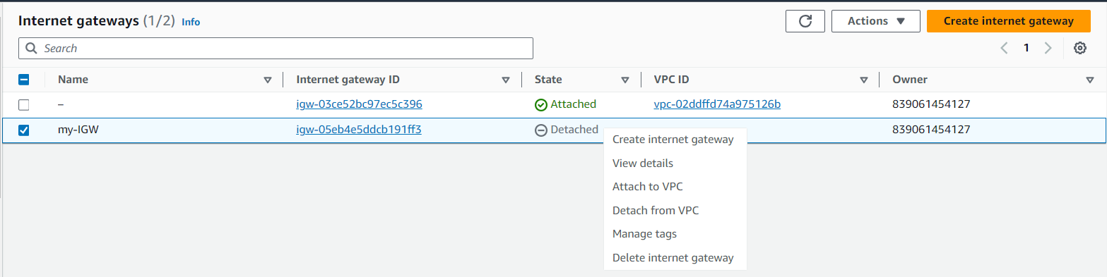

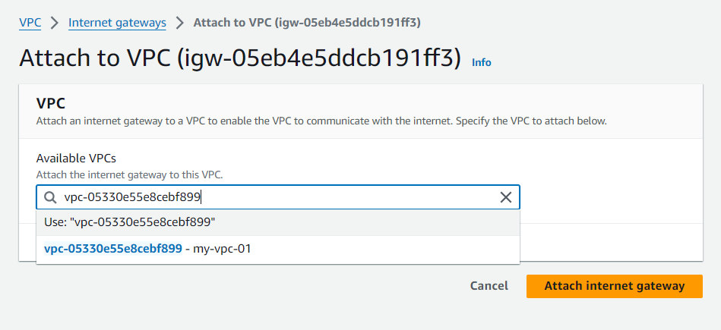

8.Go to route tables – for 2 tables – click on edit routes - give the destination 0.0.0.0/0- select required internet gateway

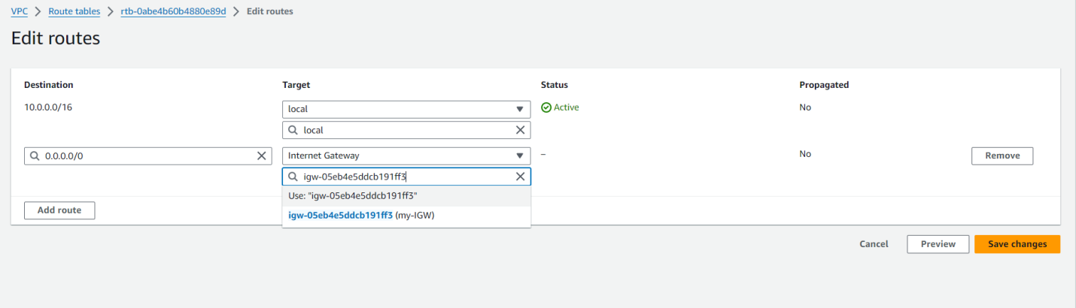

1. Go to subnet associations and click on edit subnet associations

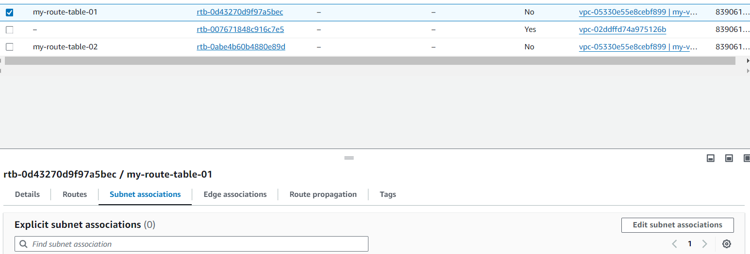

1. Click on save associations for both route tables

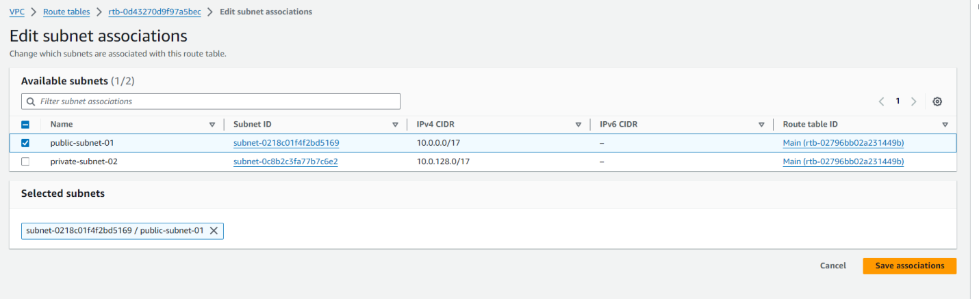

**Attaching instance with EBS volume**

1. Click on Launch Instance

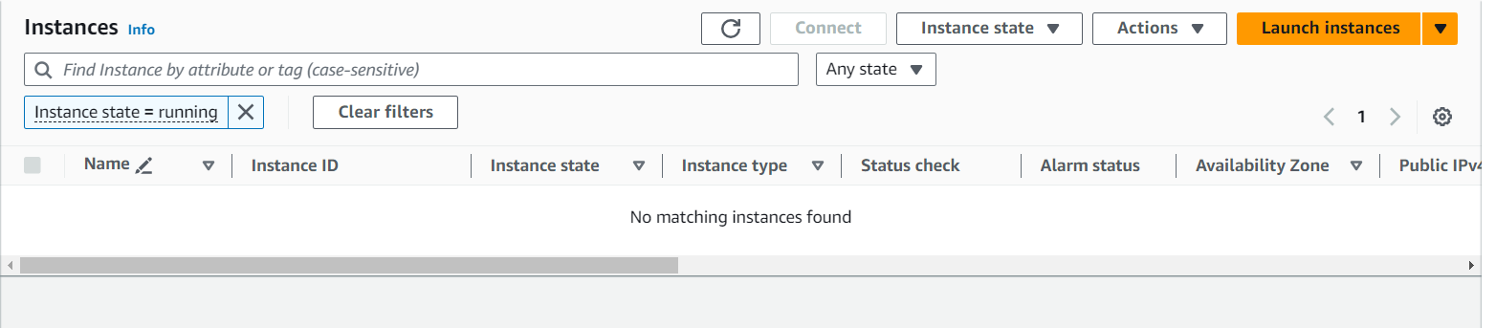

1. Enter the server name , select amazon Linux

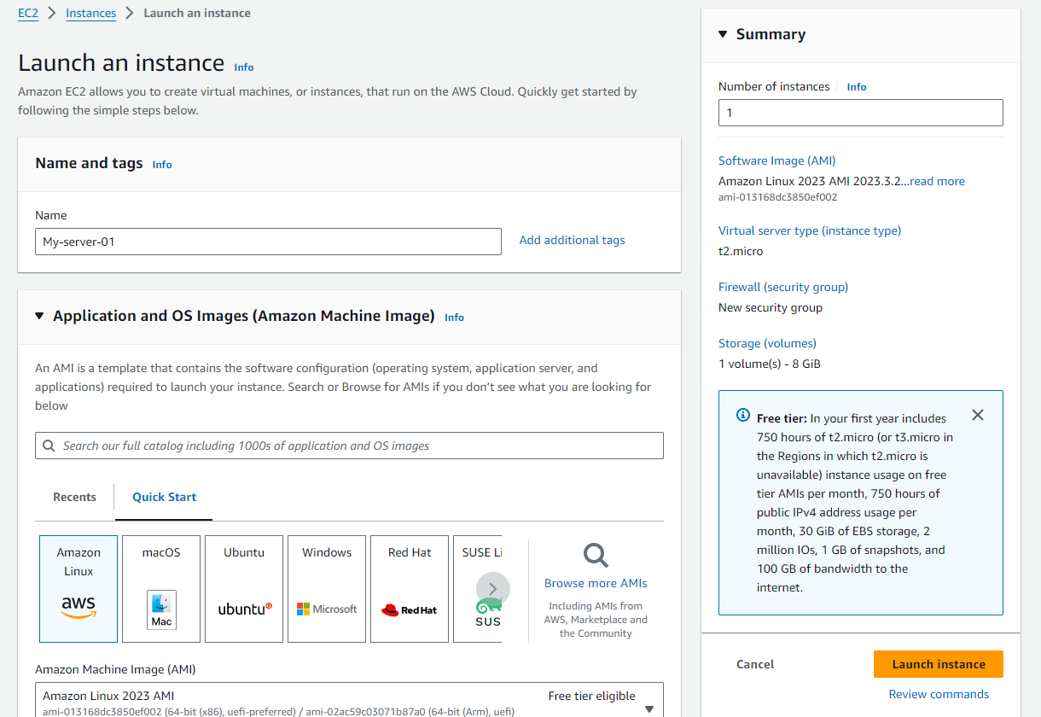

1. Create a key pair

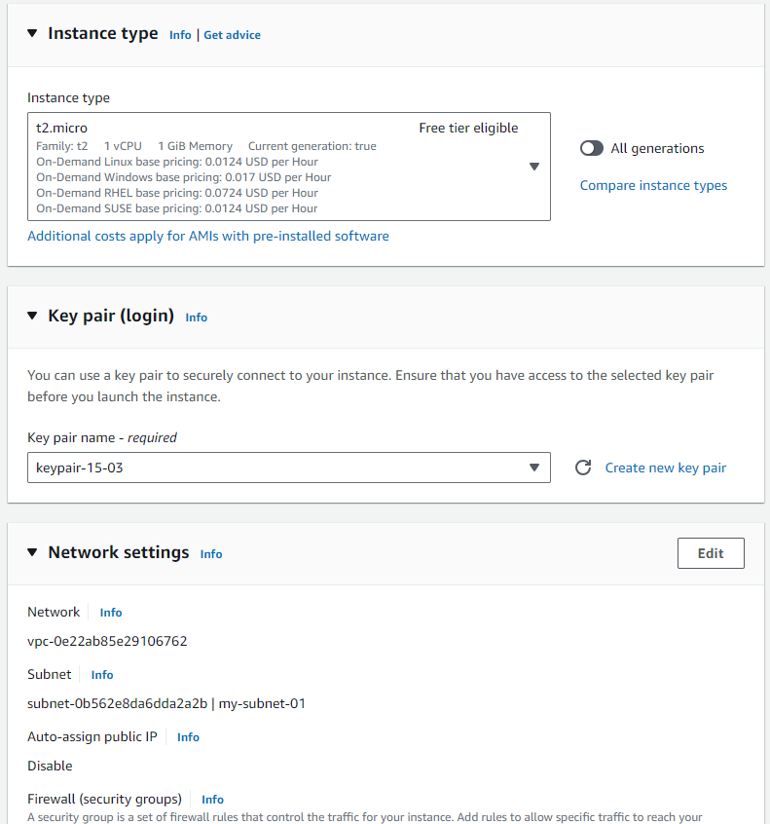

1. Click on launch instance

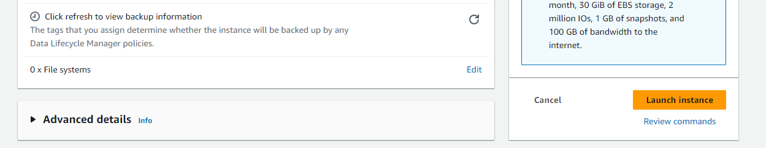

1. Instance is launched and its state is running with availability zone “ap-south-1a”



1. Click on ‘Volumes’ in Elastic Block Store drop down

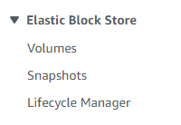

7.Click on “Create volume” and enter the Size (GiB) and click on create volume. Volume will be created.

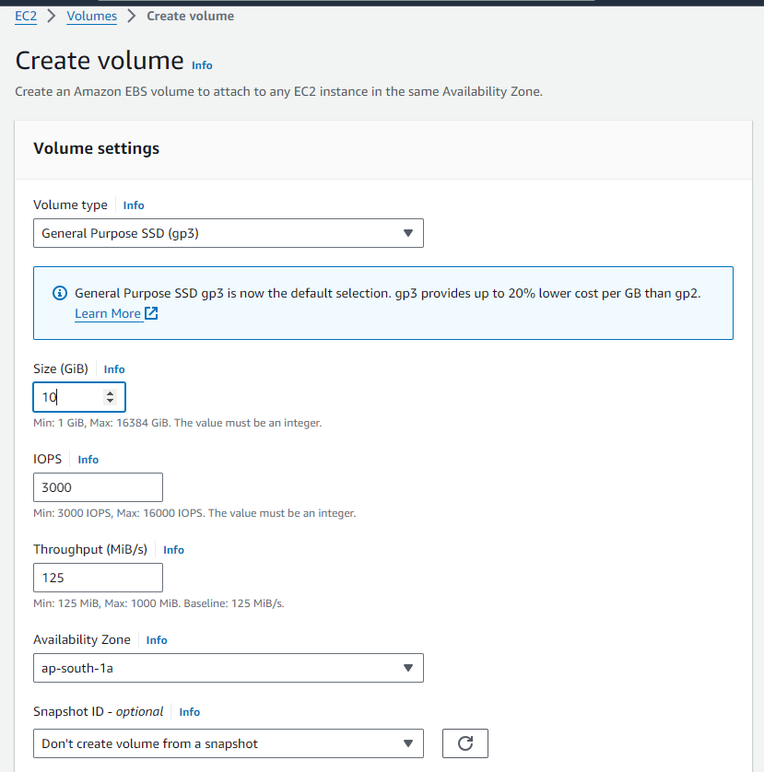

1. Click on attach volume

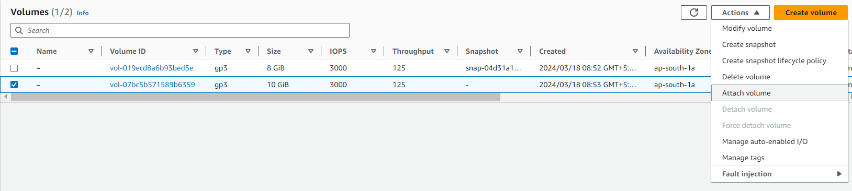

1. In Instance select running instance and select device name as /dev/sdf and click on “Attach volume”

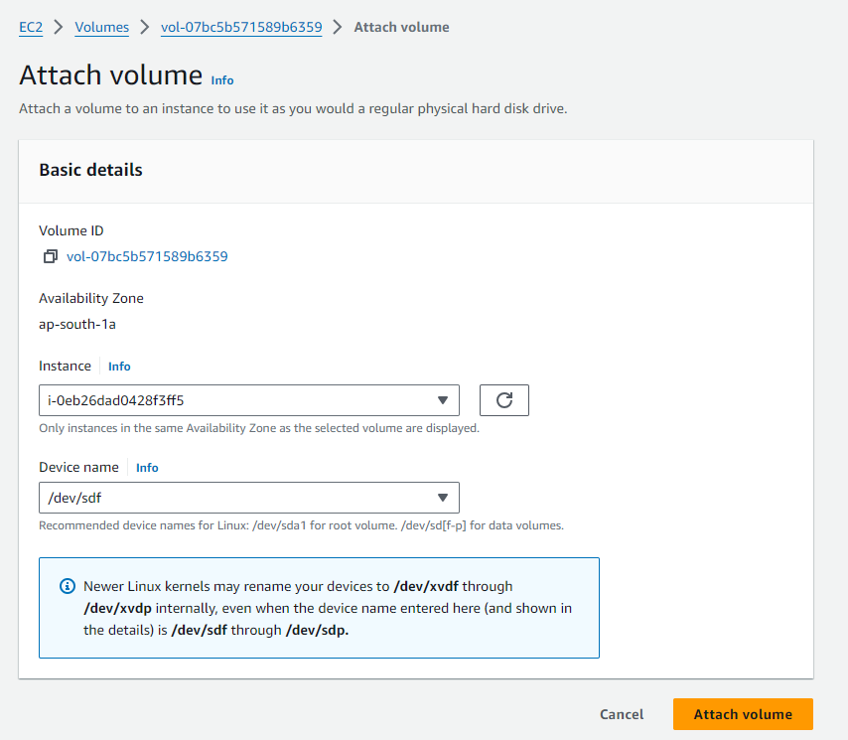

1. Check the volume status it will be “In use”
2. Now click on Instances , click on instance id and click on “connect” to connect to AWS Linux

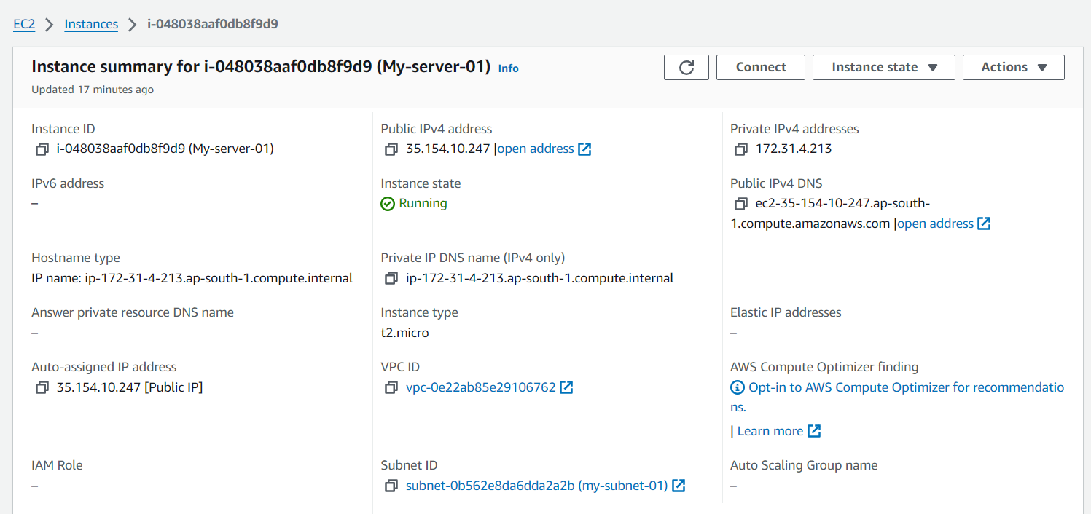

1. Login to root user by “sudo –i” command

Enter “df –h” command to know information about total space and available space on a file system.

Enter “lsblk” command to used to list oout all block devices in a tree like format

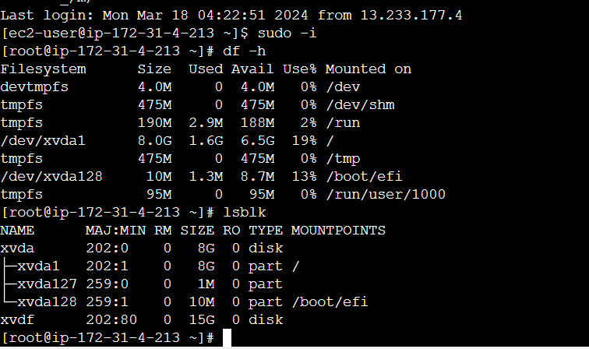

1. Create a file system

